MOOnlit Farm WebApp Features:

Start page - Logo&name, Description of the Farm

"MOOnlit Farm is a place where the everyone can stay, relax, enjoy great quality time with fictional animals, and even adopt an imaginary cow-friend for life! We offer a variety of activities which help you connect with nature and our herd. Whether you are a caretaker and will enjoy making their lives better, or you are a comforter and enjoy spending quality time with one of our very special cows - this place is for you! Browse through our selection and choose the best activity for you!"

Menu - Activities:

1. Milking

If you always wanted to find out where the milk actually comes from, and like the idea of working with animals, you can book a milking session with us. The session consists of a Farm tour, a quick training, and all the help you need. You also get to keep the milk. 😊

1. Feeding

If you always wanted to connect with animals and have that special feeling that you are taking care of them, you can book a feeding session with us. The session consists of a Farm tour, a quick training, and you will learn all the dietary needs of our horned friends.

1. Barn-cleaning

If you are a true farmer at heart, or you daydream about having your own cow kingdom one day, come see what it’s all about! The session consists of a Farm tour, a quick training, and you will learn and experience all the satisfaction of a hard day’s work.

1. Frolicking

If you just want to enjoy a fun day outdoors, surrounded by loving animals and humans, then book a frolicking session. You will get a farm tour, a meditation session, and you will be able to see, pet and even play with the horned members of our farm.

***Cowdopting***

Have you always wanted to adopt a cow, but ended up living in an apartment, or just haven’t had the space/time to care for it? Well, we have the perfect solution: COWDOPTING!

Cowdopting is a form of shared custody, where you get to make a positive impact on the animal’s life, and also be able to enjoy them as your pet. You will receive a monthly newsletter about the cow, full-time video access to the barn, and visitation rights – 2 times a month! This way, you get to enjoy and be a part of the cow’s life, and create a life-long bond with them.

CowFiction - Create your own story with Moona, our most adventurous friend.

CowProduce - Online store with fresh produce from our cows:

1. Milk
2. Cheese
3. Yogurt
4. Cream
5. Butter

Sections: FAQs, Contact US, Cow-rating,

Our Dear Friends:

1. Princess – As her name suggests, Princess is royalty, and she knows it. She expects her disciples to be obedient, and care to her every need. She likes to be brushed, fed, and absolutely pampered. And she will let you know if you are not doing a good enough job. She mostly likes to sit and rest, as being cared for 24/7 can be very exhausting…

Princess enjoying a well-deserved rest.

1. MooDonna – MooDonna is a star. She was born to sing, and that is exactly what she is doing – all day, every day. In the morning, she is the one waking up the roosters. In the afternoon, she sings moollabies so that you can take a nap. And in the evening, she gives the greatest concerts you have ever heard. She will sing your ear off, and you will love her for it.

MooDonna's greatest performance.

1. Oreo – Oreo is just sooooo sweet. She loves love, and will do anything to be around people and show affection. She will sit with her head on your lap, let you pet and hug her for hours, and give you a good lick to say good-bye. She enjoys every minute of it, and so will you.

1. Rocket – Rocket thinks she’s a dog. She loves to play, do crazy stunts, and is a football STAR! She can kick a ball, chase it, and score goals like no other. If you also like fun outdoor activities, then you will love to spend time with Rocket.

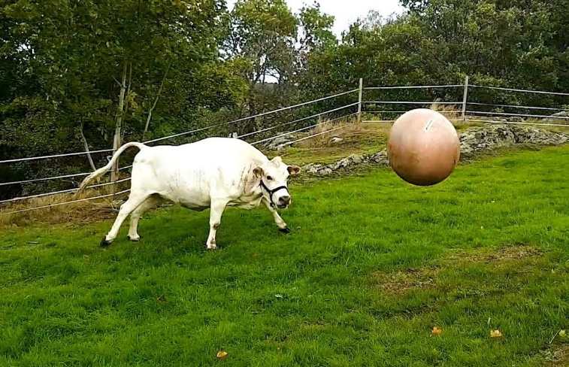

1. Bean – Bean is a very unpretentious cow. She loves to be on a farm, and thinks that giving milk is the best gift she can give to the world. She likes the simple things in life, and knows that the key to the fountain of knowledge is nothing else than a good nose-lick.

